# Tribute Web Page

### A MINI PROJECTREPORT

#### Submitted by

#### Group/Team No: G17(B)/T18

**Vansh, 2210992497,**

**Vansh Pant, 2210992498,**

**Vansh Thakur, 2210992499,**

**Vanshaj Sharma,2210992500**

#### in partial fulfillment for the award of the degree of

## BACHELEOR OF ENGINEERING

***in***

COMPUTER SCIENCE & ENGINEERING



**CHITKARA UNIVERSITY**

**CHANDIGARH-PATIALA NATIONAL HIGHWAY**

**RAJPURA (PATIALA) PUNJAB-140401 (INDIA)**

##### MAY 2023

TABLE OF CONTENTS

|  |  |  |
| --- | --- | --- |
| Sr.no | Section | Page no |
| 1 | Introduction | 1 |
| 2 | Problem Statement | 2 |
| 3 | Technical details | 3-4 |
| 4 | Key features | 5-9 |
| 5 | Project highlights | 9-10 |
| 6 | Refrence Link | 10-11 |
| 7 | Conclusion |  |

1. **Introduction**

Title: Survey Form

* Overview: An employee survey form is a tool that is used by organizations to gather feedback from employees about various aspects of their work environment, job satisfaction, performance, and other relevant factors that affect their work. The form typically includes a range of questions designed to assess the employee's opinions and experiences related to their job and workplace..
* Employee surveys are a valuable tool for organizations to gather feedback from their employees. These surveys can help identify areas for improvement, measure employee satisfaction, and inform decision-making processes.
* Creating an effective employee survey requires thoughtful planning and consideration of various factors such as the survey questions, format, and distribution method.

Problem Statement

A possible problem statement for a Employee survey form project could be:

Our company wants to collect feedback from its employees to understand their satisfaction levels, work-related issues, and suggestions for improvement. However, the current approach of collecting feedback through informal discussions or one-on-one meetings is not scalable and lacks structure. Therefore, we need to create an employee survey form that is easy to fill, comprehensive, and can gather actionable insights. The form should be able to capture employees' feedback on various aspects such as work environment, work-life balance, compensation and benefits, job satisfaction, growth opportunities, and overall management. The survey form should also ensure employee anonymity to encourage honest feedback. The challenge is to create a survey form that can gather relevant and insightful feedback, analyze the responses, and use the findings to improve the company's policies and practices.



Technical Details

Overview of Technologies and Methods Used:

* Our Survey form was developed using a combination of HTML, CSS, and JavaScript. We utilized HTML to structure the content of the web page, CSS to style the page and create the visual design, and JavaScript to add interactivity and dynamic elements to the page.
* To ensure effective collaboration among team members, we utilized project management tools such as Replit and VS code. These tools allowed us to track tasks, assign responsibilities, and share resources and documents in real-time
* Overall, the combination of technical skills and effective project management strategies allowed us to develop a high-quality tribute web page that effectively honored the person being recognized and provided a positive user experience for visitors.



Java Script Used:

The given code snippet is a JavaScript function named ‘submitForm’ that is triggered when a form is submitted. Let's break down the function step by step:

The JavaScript code in the this HTML web page is performing the following tasks:

* `event.preventDefault();`: This line prevents the default form submission behavior, ensuring that the form data is not sent to the server immediately.
* The next several lines retrieve the values entered by the user in various form fields using the `getElementById` and `querySelector` methods. Here's a summary of the variables being assigned:

- `name`: The value of the element with the ID "name".

- `email`: The value of the element with the ID "email".

- `date`: The value of the element with the ID "date".

- `phone`: The value of the element with the ID "phone".

- `gender`: The value of the selected radio button with the name "g".

- `satisfaction`: The value of the selected radio button with the name "recommed-1".

- `role`: The value of the element with the ID "role".

- `valued`: The value of the selected radio button with the name "recommed-2", or an empty string if no radio button is selected.

- `valuedExplanation`: The value of the element with the ID "valued-explanation".

- `stress`: The value of the selected radio button with the name "recommed-3", or an empty string if no radio button is selected.

- `stressExplanation`: The value of the element with the ID "stress-explanation".

- `solicitOpinions`: The value of the selected radio button with the name "recommed-4", or an empty string if no radio button is selected.

- `comments`: The value of the element with the ID "comments".

* After retrieving the form values, you can perform any additional validation or manipulation of the data as needed.
* The following lines log the form values to the console. This is useful for testing purposes to verify that the form data is being captured correctly.
* `document.getElementById("form").reset();`: This line resets the form, clearing all input fields.
* Overall, this function captures form data, performs validation (if implemented), logs the values to the console, and resets the form. However, it does not actually send the form data to the server for processing. You would need to add additional logic to send the form data to a server or perform any desired actions with the data.

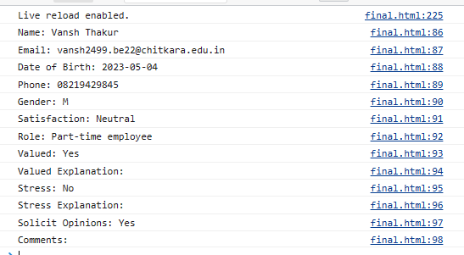

Key Features

**Key Features Needed to Solve the Problem:**

* . **Relevant questions:** The survey questions should be relevant to the purpose of the survey and related to the topics that you want to explore. The questions should be clear, concise, and avoid technical jargon.
* . **Anonymity:** Ensure that the survey responses are anonymous to encourage honest feedback. Employees should feel comfortable sharing their thoughts and opinions without any fear of retribution.
* **Mix of question types:** Use a mix of open-ended and closed-ended questions to gather both quantitative and qualitative data. Open-ended questions provide employees with the opportunity to share their thoughts and feelings, while closed-ended questions provide specific data points that are easy to analyze.
* **Customization options:** Provide customization options in the survey form so that employees can skip questions that are not relevant to them or provide additional comments where necessary. This will help ensure that the survey responses are accurate and comprehensive.
* . **User-friendly design:** The survey form should have a user-friendly design that is easy to navigate and understand. Use a clear layout, readable fonts, and consistent formatting to make it easy for employees to complete the survey.

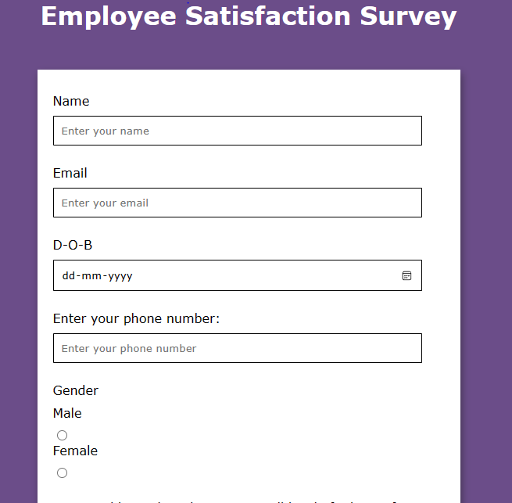

Project Highlights

This is a HTML file that represents a Survey form dedicated to the Employee Survey Form. The web page contains various sections such as the navigation menu, an image, a paragraph that provides a brief overview of the Questions, and other details.

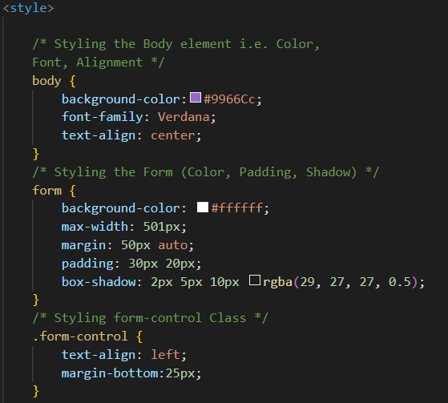

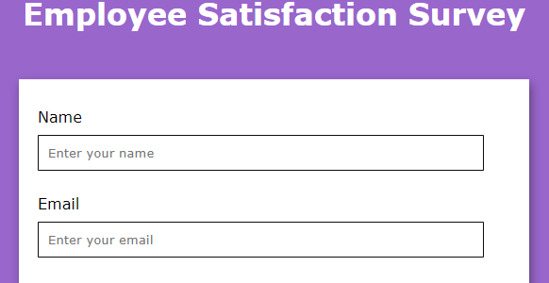

The web page also contains several CSS styles that are used to format the various elements of the page. For example, the CSS style for the <body> tag sets the background image of the page, and the <style> tag contains other CSS styles such as font size, background color, and text alignment.

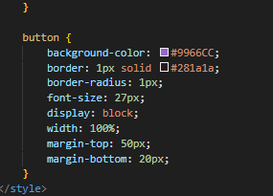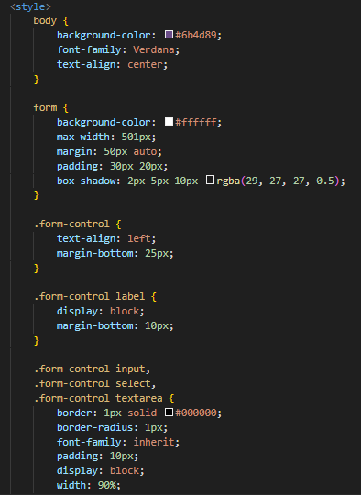

Some important questions:

1.Demographic Information: This section collects basic details about the employee, such as their name, department, position, and length of employment. It helps to categorize and analyze the responses based on different employee groups.

2.Multiple-choice or Likert Scale Questions: These are structured questions that allow employees to select a response from a predefined set of options. For example, employees may be asked to rate their level of satisfaction on a scale from 1 to 5 or choose from options like "strongly agree," "agree," "neutral," "disagree," or "strongly disagree."

3. Job Satisfaction and Engagement: This section focuses on gauging employees' satisfaction with their roles, responsibilities, workload, work-life balance, career growth opportunities, and their level of engagement within the organization.

4. Overall Feedback: This is an opportunity for employees to provide general feedback or suggestions not covered in other sections of the survey.

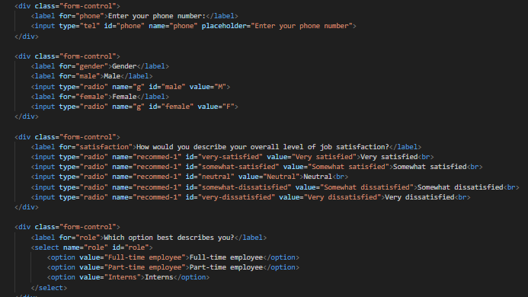

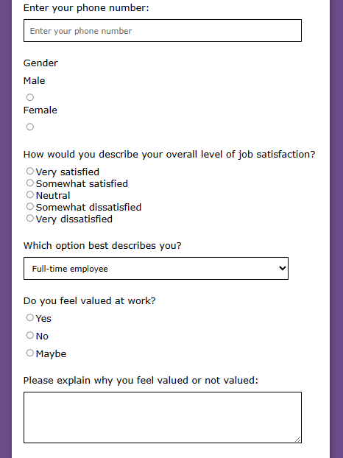

References

HTML element reference: <https://developer.mozilla.org/en-US/docs/Web/HTML/Element>

CSS property reference: <https://developer.mozilla.org/en-US/docs/Web/CSS/Reference>

Input types for HTML forms: <https://developer.mozilla.org/en-US/docs/Web/HTML/Element/input>

HTML radio button guide: <https://developer.mozilla.org/en-US/docs/Web/HTML/Element/input/radio>

Conclusion

In conclusion, creating an employee survey form is an effective way to gather feedback from employees and identify areas of improvement in the workplace. A well-designed survey form with relevant questions, anonymity, a mix of question types, a user-friendly design, mobile responsiveness, progress indicators, and customization options will encourage honest feedback and provide actionable insights. By analyzing the survey responses, companies can make data-driven decisions and implement changes that improve employee satisfaction, retention, and productivity. It's essential to involve employees in the process of creating the survey form to ensure that the questions are relevant and meaningful. Overall, making an employee survey form requires careful planning, attention to detail, and a commitment to using the findings to drive positive change in the workplace.



